**Short Term Trading Using Monthly** & **Weekly Ranges**

This is ICTs go to trading style, his favourite. If he cant find a one shot one kill, he goes to day trading for the week

These setups form every week, so theres no need to FOMO

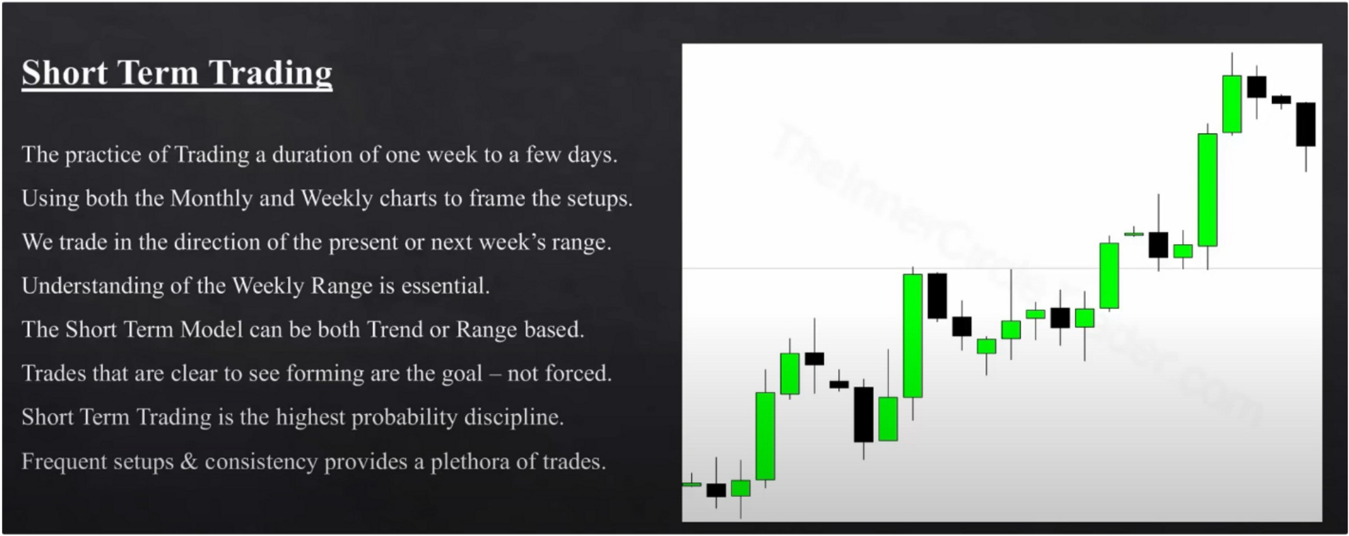

Its important to go trough the january and february notes, because they will compliment things in this month and he wont go over those things again all the time. Go trough all the months notes again when you finish a month

The things missing from the swing model will be touched on in the lower timeframe models. everything connects together

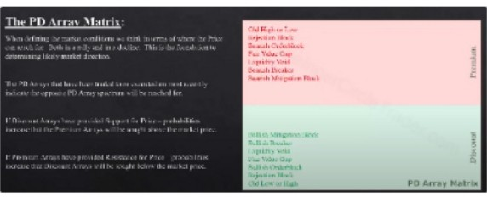

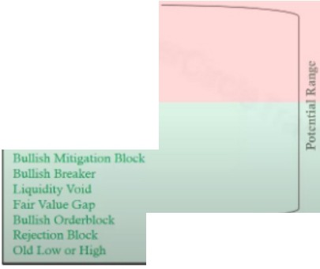

OldHdi,orLow

,,.,..,mod;

.u.1b lod.:

,L,J,q.u,1,J,..1.1,y.\l.o.tJ,,

l:INnsh Mt11g.1uon Block

f'oMrV.llueG.lp

e.nisb M,upoon IAod;. RuhRr.:ll.CT l.JqUIJ.cyVOW r.mV.?u,.l1'"JI

ttwlubOrlkd,!ixt Rr:,el;honBloclr.

VJJl. ,,,rllq:h

---

PO Array Matrix

OIJlhJU'url. ,

"'1«0011tslo<:lr.

rk,.n,,hOn.l<,.-rl,h,.l r.urV.UucC.<ir L1qwdl.1y\'0111

Jk,1m.hJlr.:..J..a-

MIS.b Mllag.atlOn filock

PD Array Matrix

You hold for the entire potential range, and ofcourse with partials in the meantime

All were doing is looking for a monthly PD array based on our directional bias, and then look for an opposing weekly PD array and thats your target thats your range. Thats what ICT uses to call the market. If he isnt confident its because he doesnt know which PD array is going to be used next so he waits for more informaiton, or the PD arrays have been expired theyve already been traded to so you have to wait

Look for all the PD arrays on the Monthly, weekly, daily and 4h. Because if we outline our premium and discount arrays and were bearish we want to see the discount arrays break contuniusly until we get to the weekly discount array

**Oi+I**

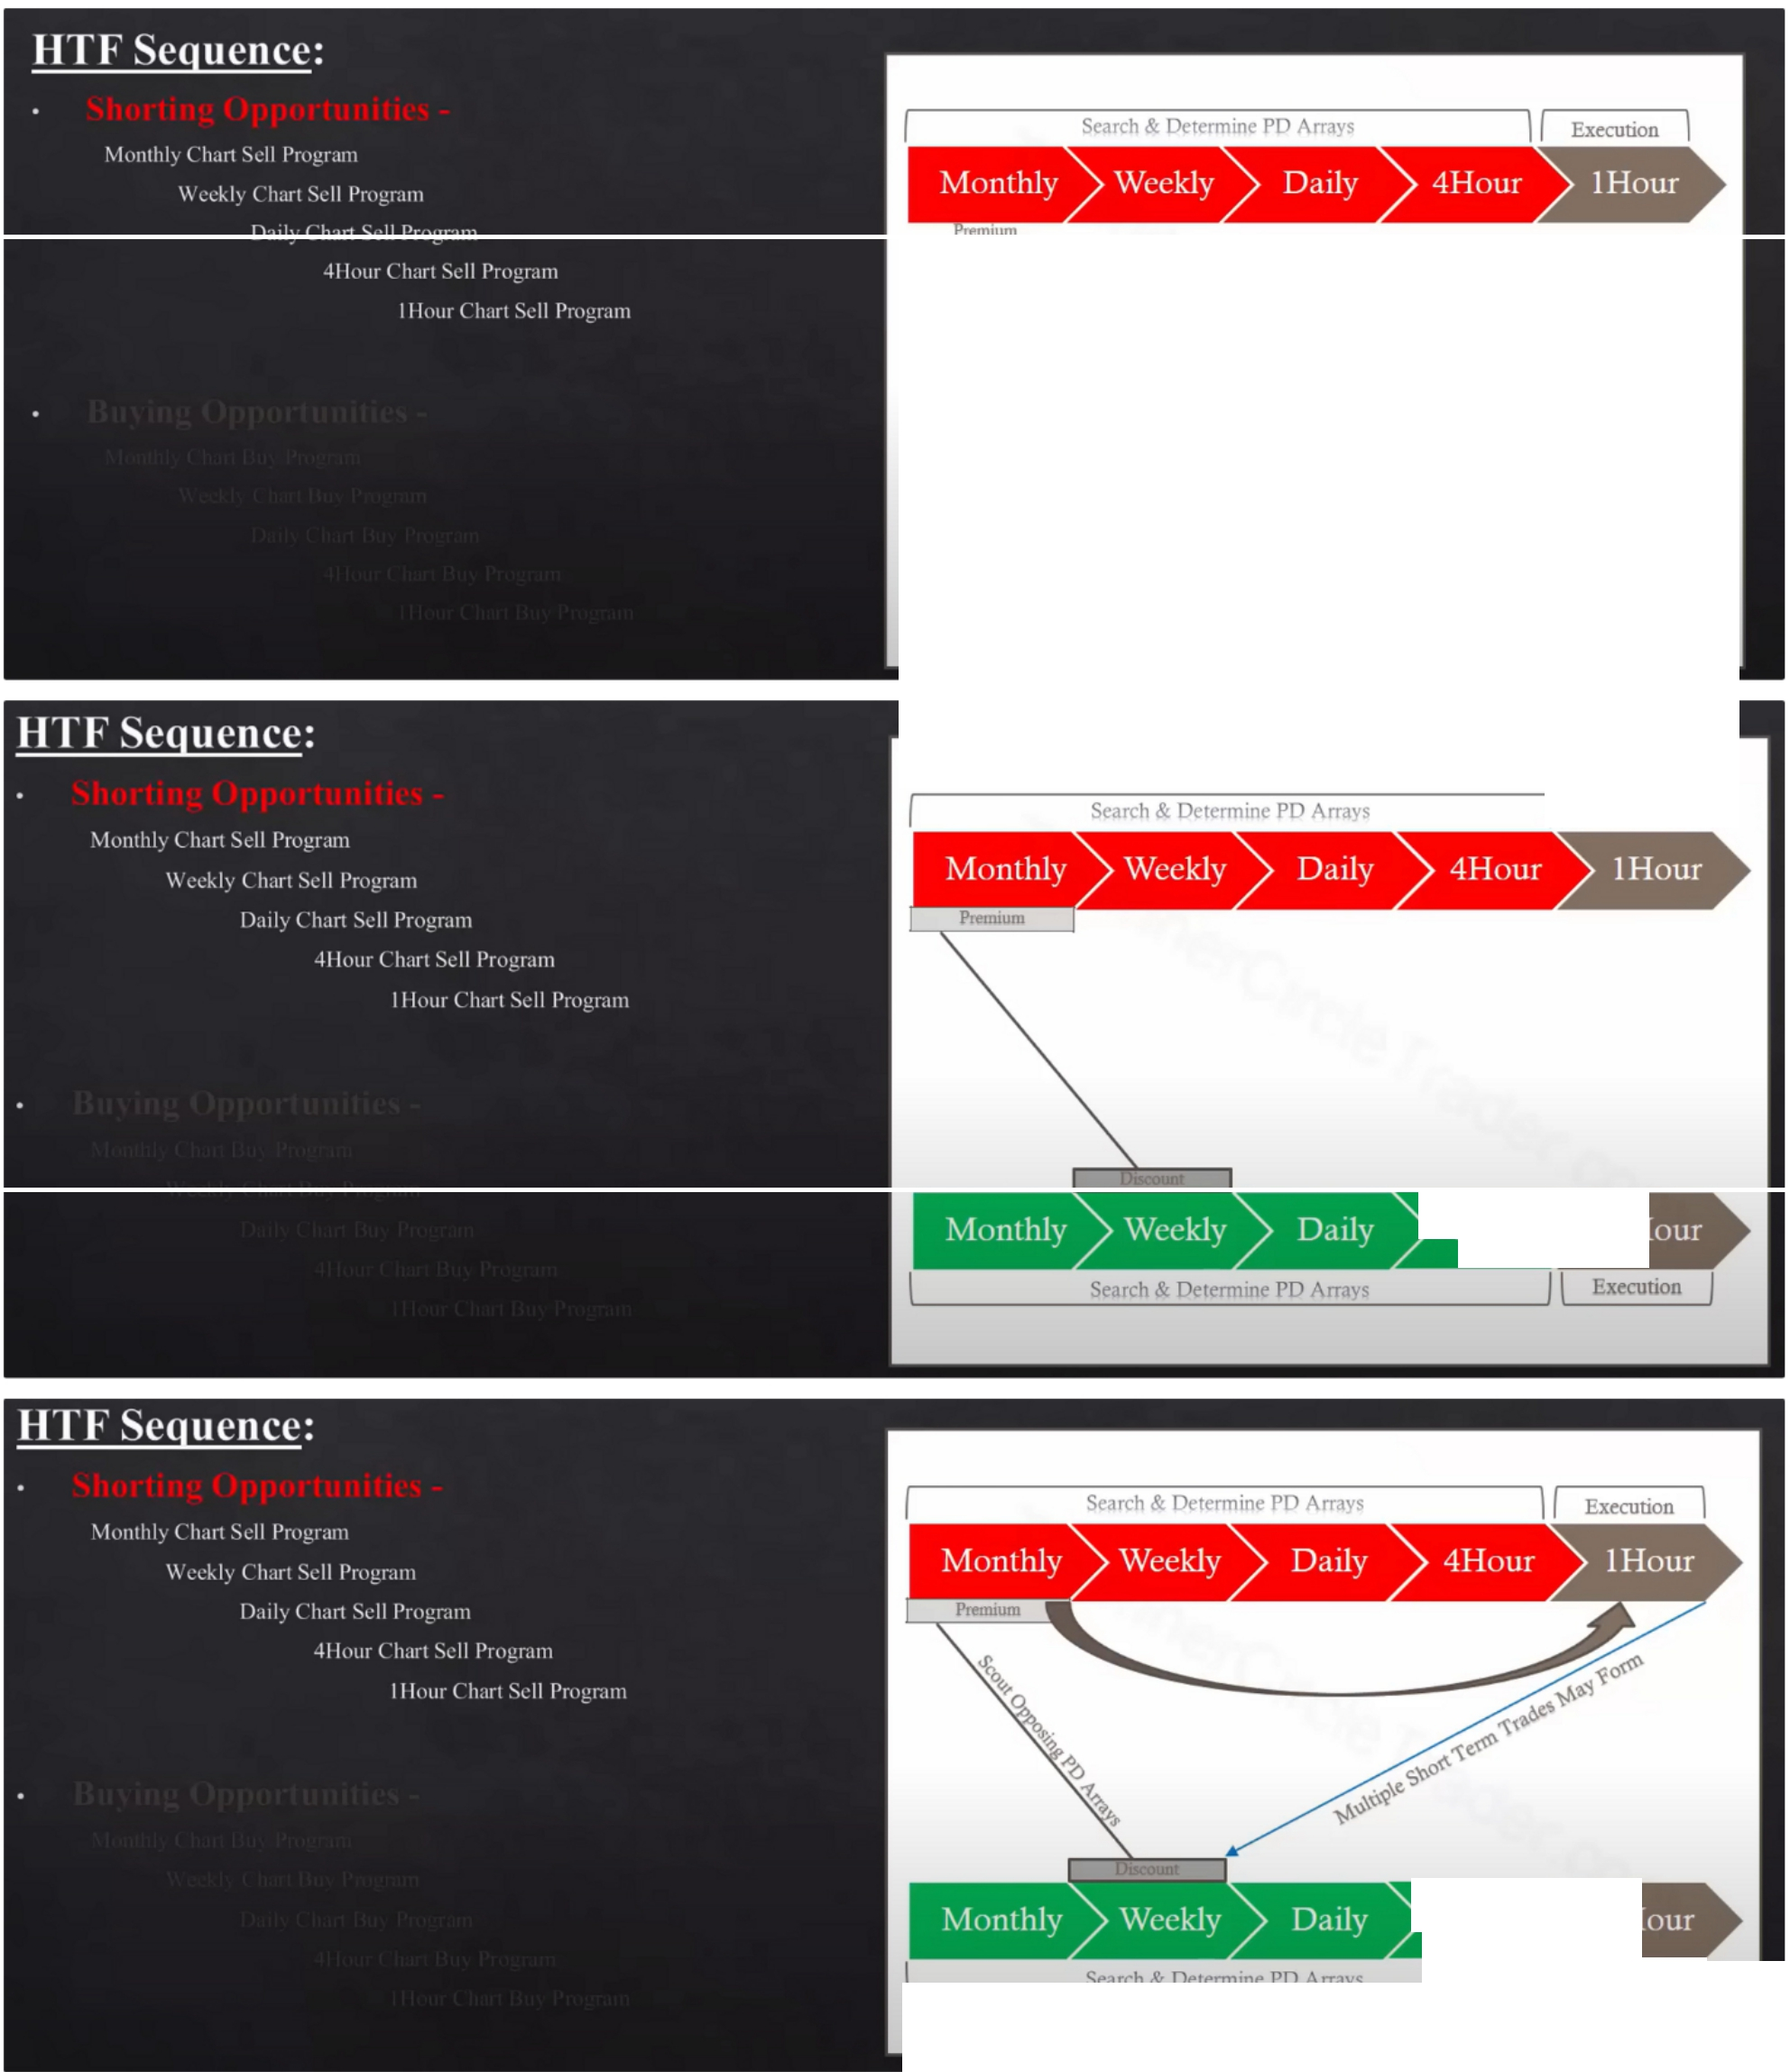

**EIIIIHlll·&iiRHi+i**■ ►

\ **Se:irch & Oete-nnme PD** ,\rr.1\ ***J* \ Execution j**

\I Execution \

**\*Hi!HEO**

**\*\HHFO**

/ I

Execunon /

1h is our executable chart no matter what timeframe the array is on

If you notice price is already moving away from the monthly premium then drop down to the weekly and whats the weekly array or the daily or 4h

If its from a HTF array you might see multiple short term trades form, if its from a 4h array then you will likely not see so many setups form, but sitll high probability

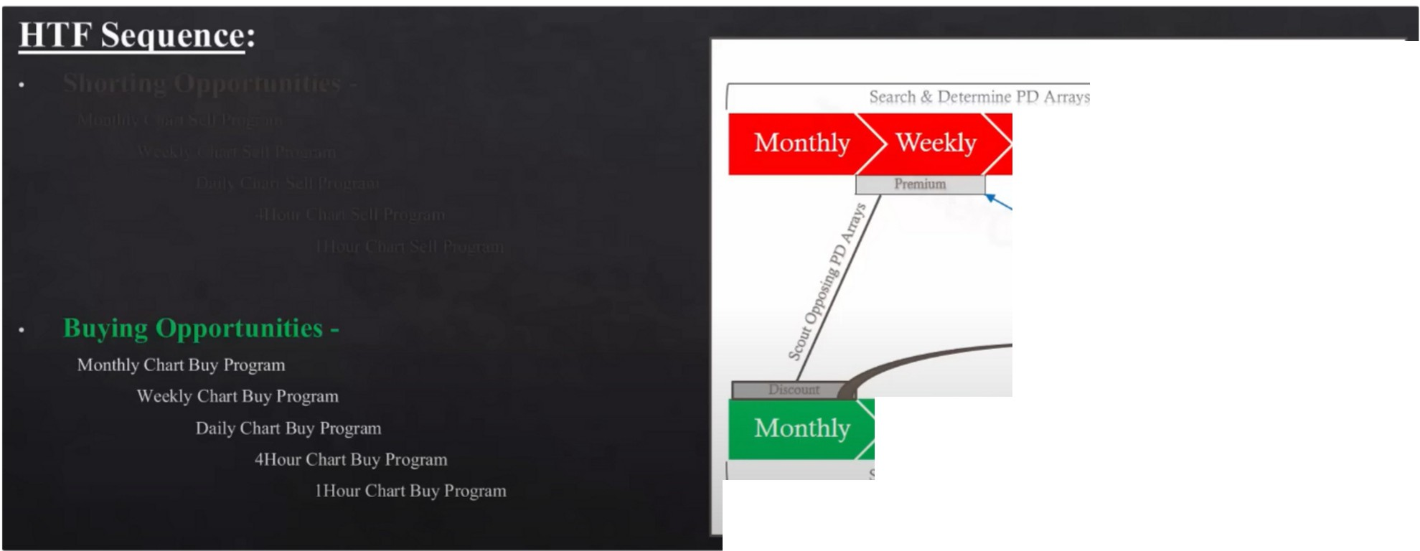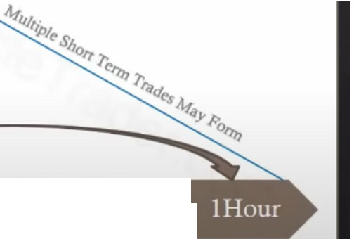

••

**iii!M**■**ffrH**►

11 Execution I

II Execunon

**i'ff!ii·iiHM+i**►

From a weekly PD array instead of monthly, this is one shot one kill setup. This is what has consistent setups every single week, ICTs bread and butter

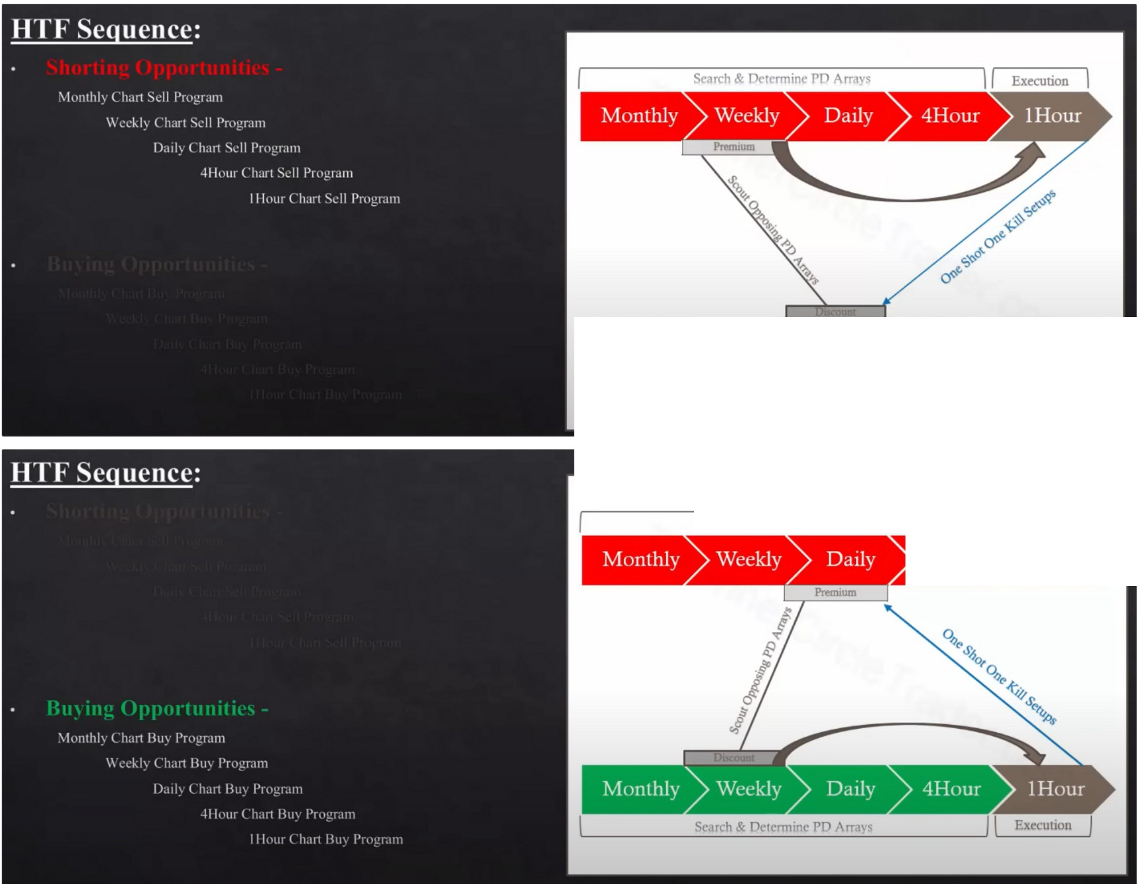

I II Execution I

**Eiiiii'·i!I**

**+IHMOi+i**►

**Search & Determine PD Arrays**

■**ffrH**►

11 Execution I

**ifiifM**

Execute on every array from the 1h chart The swing trade progression:

- **Short Term Trading Model**

[l I I I l I) \I 11 \ \ \\ l t f.. \ is 117 < I

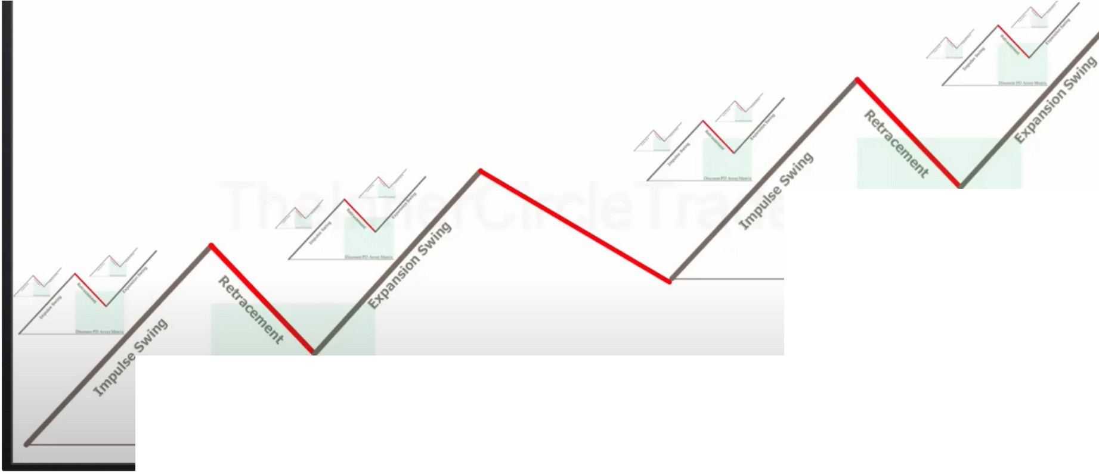

**Discount PD Arra Matrix**

**Discount PD Array \1atrh**

**Bullish Markets**

Theres potential 16 buying opportunities in this fractal, and thats not counting any short term trades on the retracement because those can also be traded.

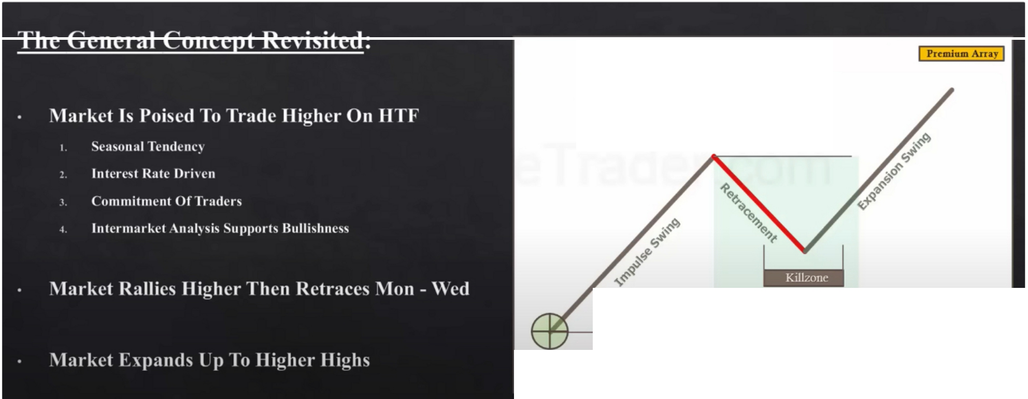

**Monday Tuesday Wednesday**

**Discount PO Arra Matrix**

[?)@Olli){l*@1* llil

**Bullish Markets**

The retracement can also happen monday, its between monday and wednesday The PD array is applied from monday to wednesday, not just on wednesday ofc

6pm to 9pm is sweet spot for asia, for asian pairs. The closer you get to 1Opm the worse because 1O is lunch time

1h PD array can be also executed on inside killzone

We dont have to have the seasonal tendency on our side

# The General Conce t Revisited:

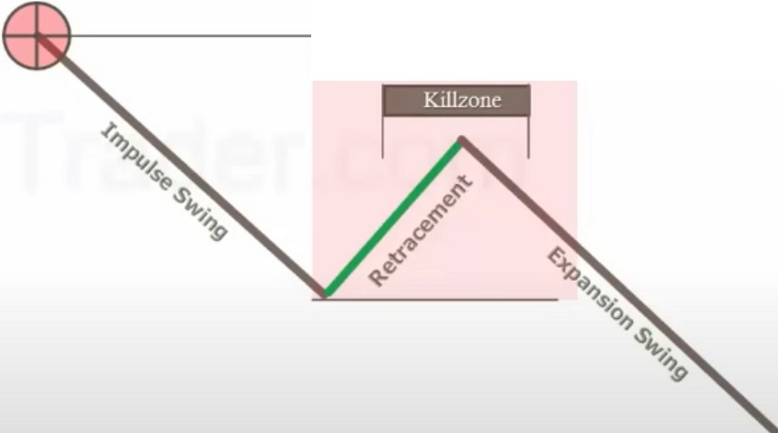

[ii>®l'lllilfi *@t1* Dllil

**Bearish Markets**

Premium PD Array Matrix

Monda) Tuesday Wcdncsda)

ID1sc... 1Amy I

Market Is Poised To Trade Lower On HTF

Seasonal Tcndcnc Interest Rate l>riwn Commitment Of Trader,

lntcrnrnrket .\1,al sis Supports Bearisl111<·ss

\larkl't Dl'clinl's Lowl'r Then Retracl's \Ion - Wl'd

\larkl'I Expands Down To Lowl'r Lows

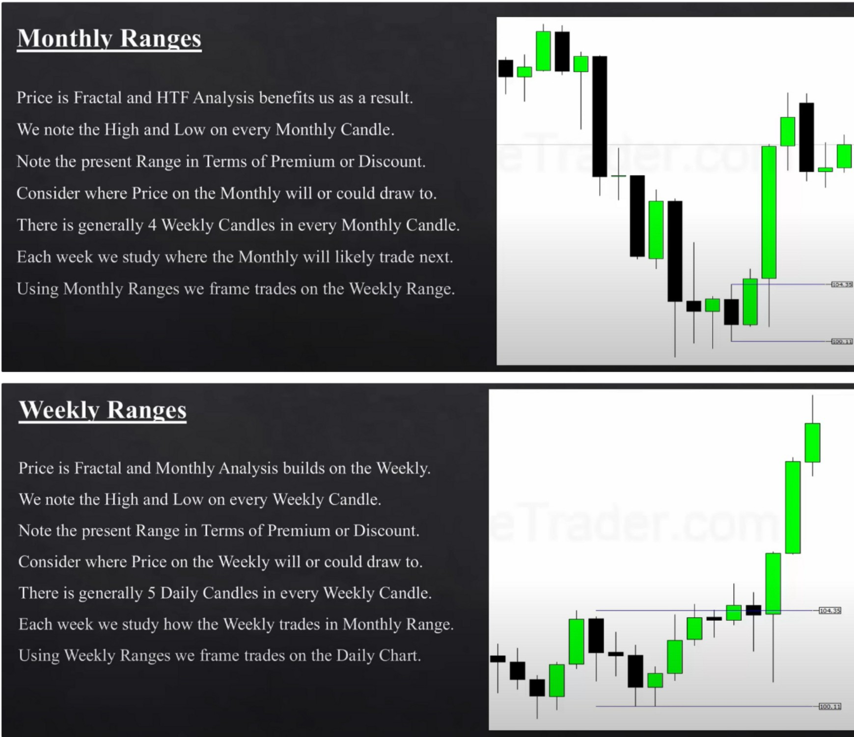

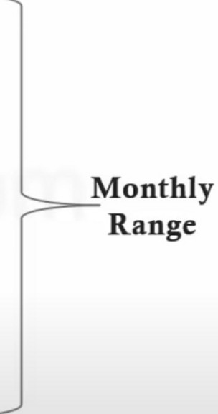

**Look For Lo**

**In Th"ts Ranngges**

,, 11111

l

Ut!

I' 1111 ==--

11 _l_ _111 ---

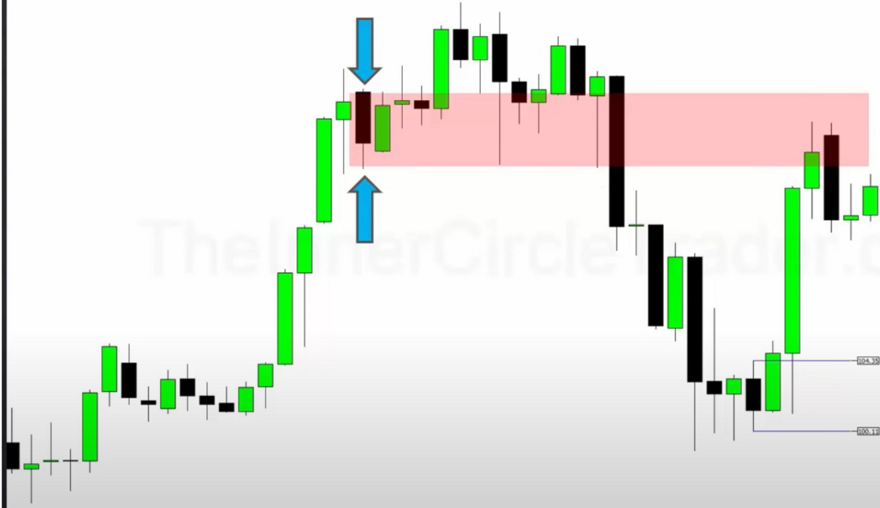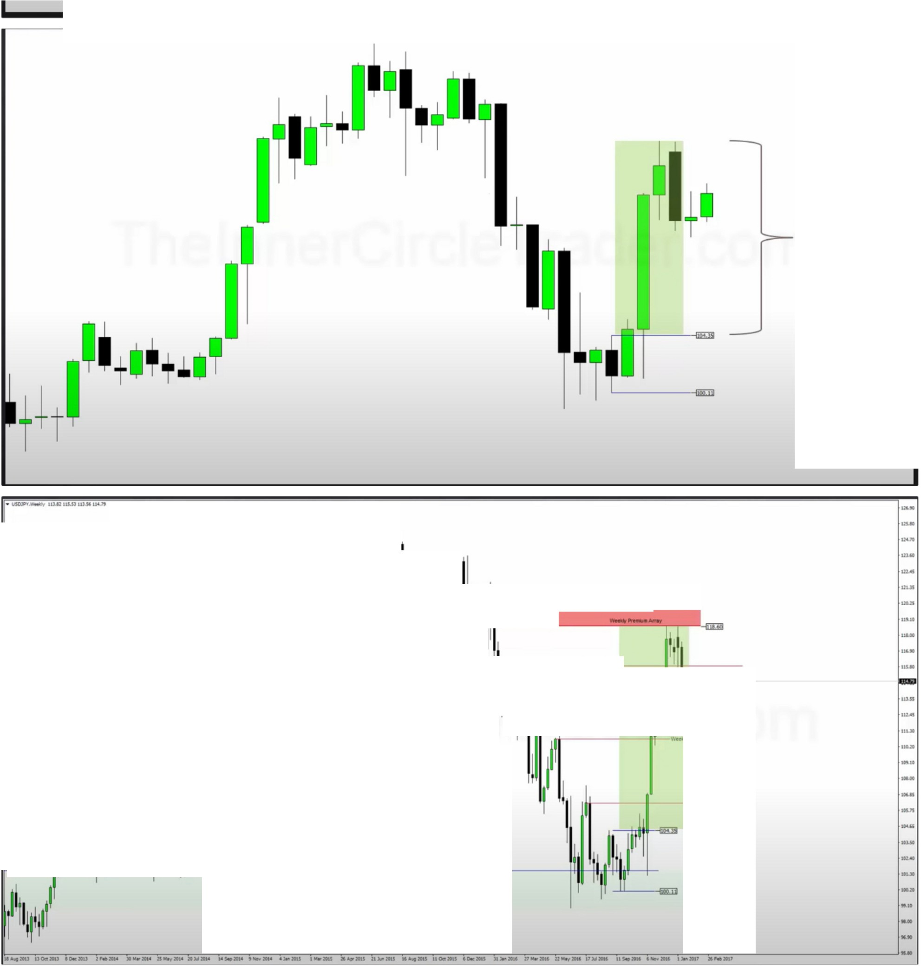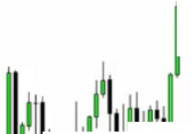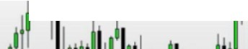

I'

**-------,11°11!lfl ll'_ll_llll'l!II 11**

---

11I1

1-11-/

**-w..,.._-.,**

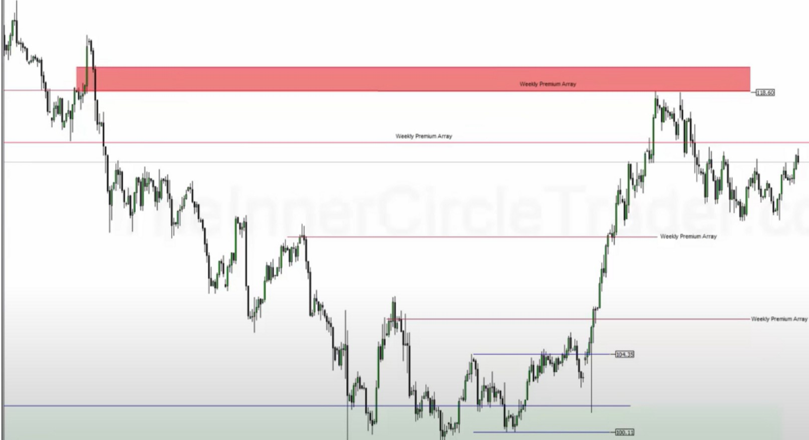

**II-Ml •-as** ·-- ·-- ·-- **16 ...-.** ..._. **Z.I.-.** II...,_ • ...,_.,,..._ ,,.._ .,.._ u ..-. **J.I.-. *ns.-* 1CM- •oa-** "-- ,-- n-- **u,....,** ·--, , , ..

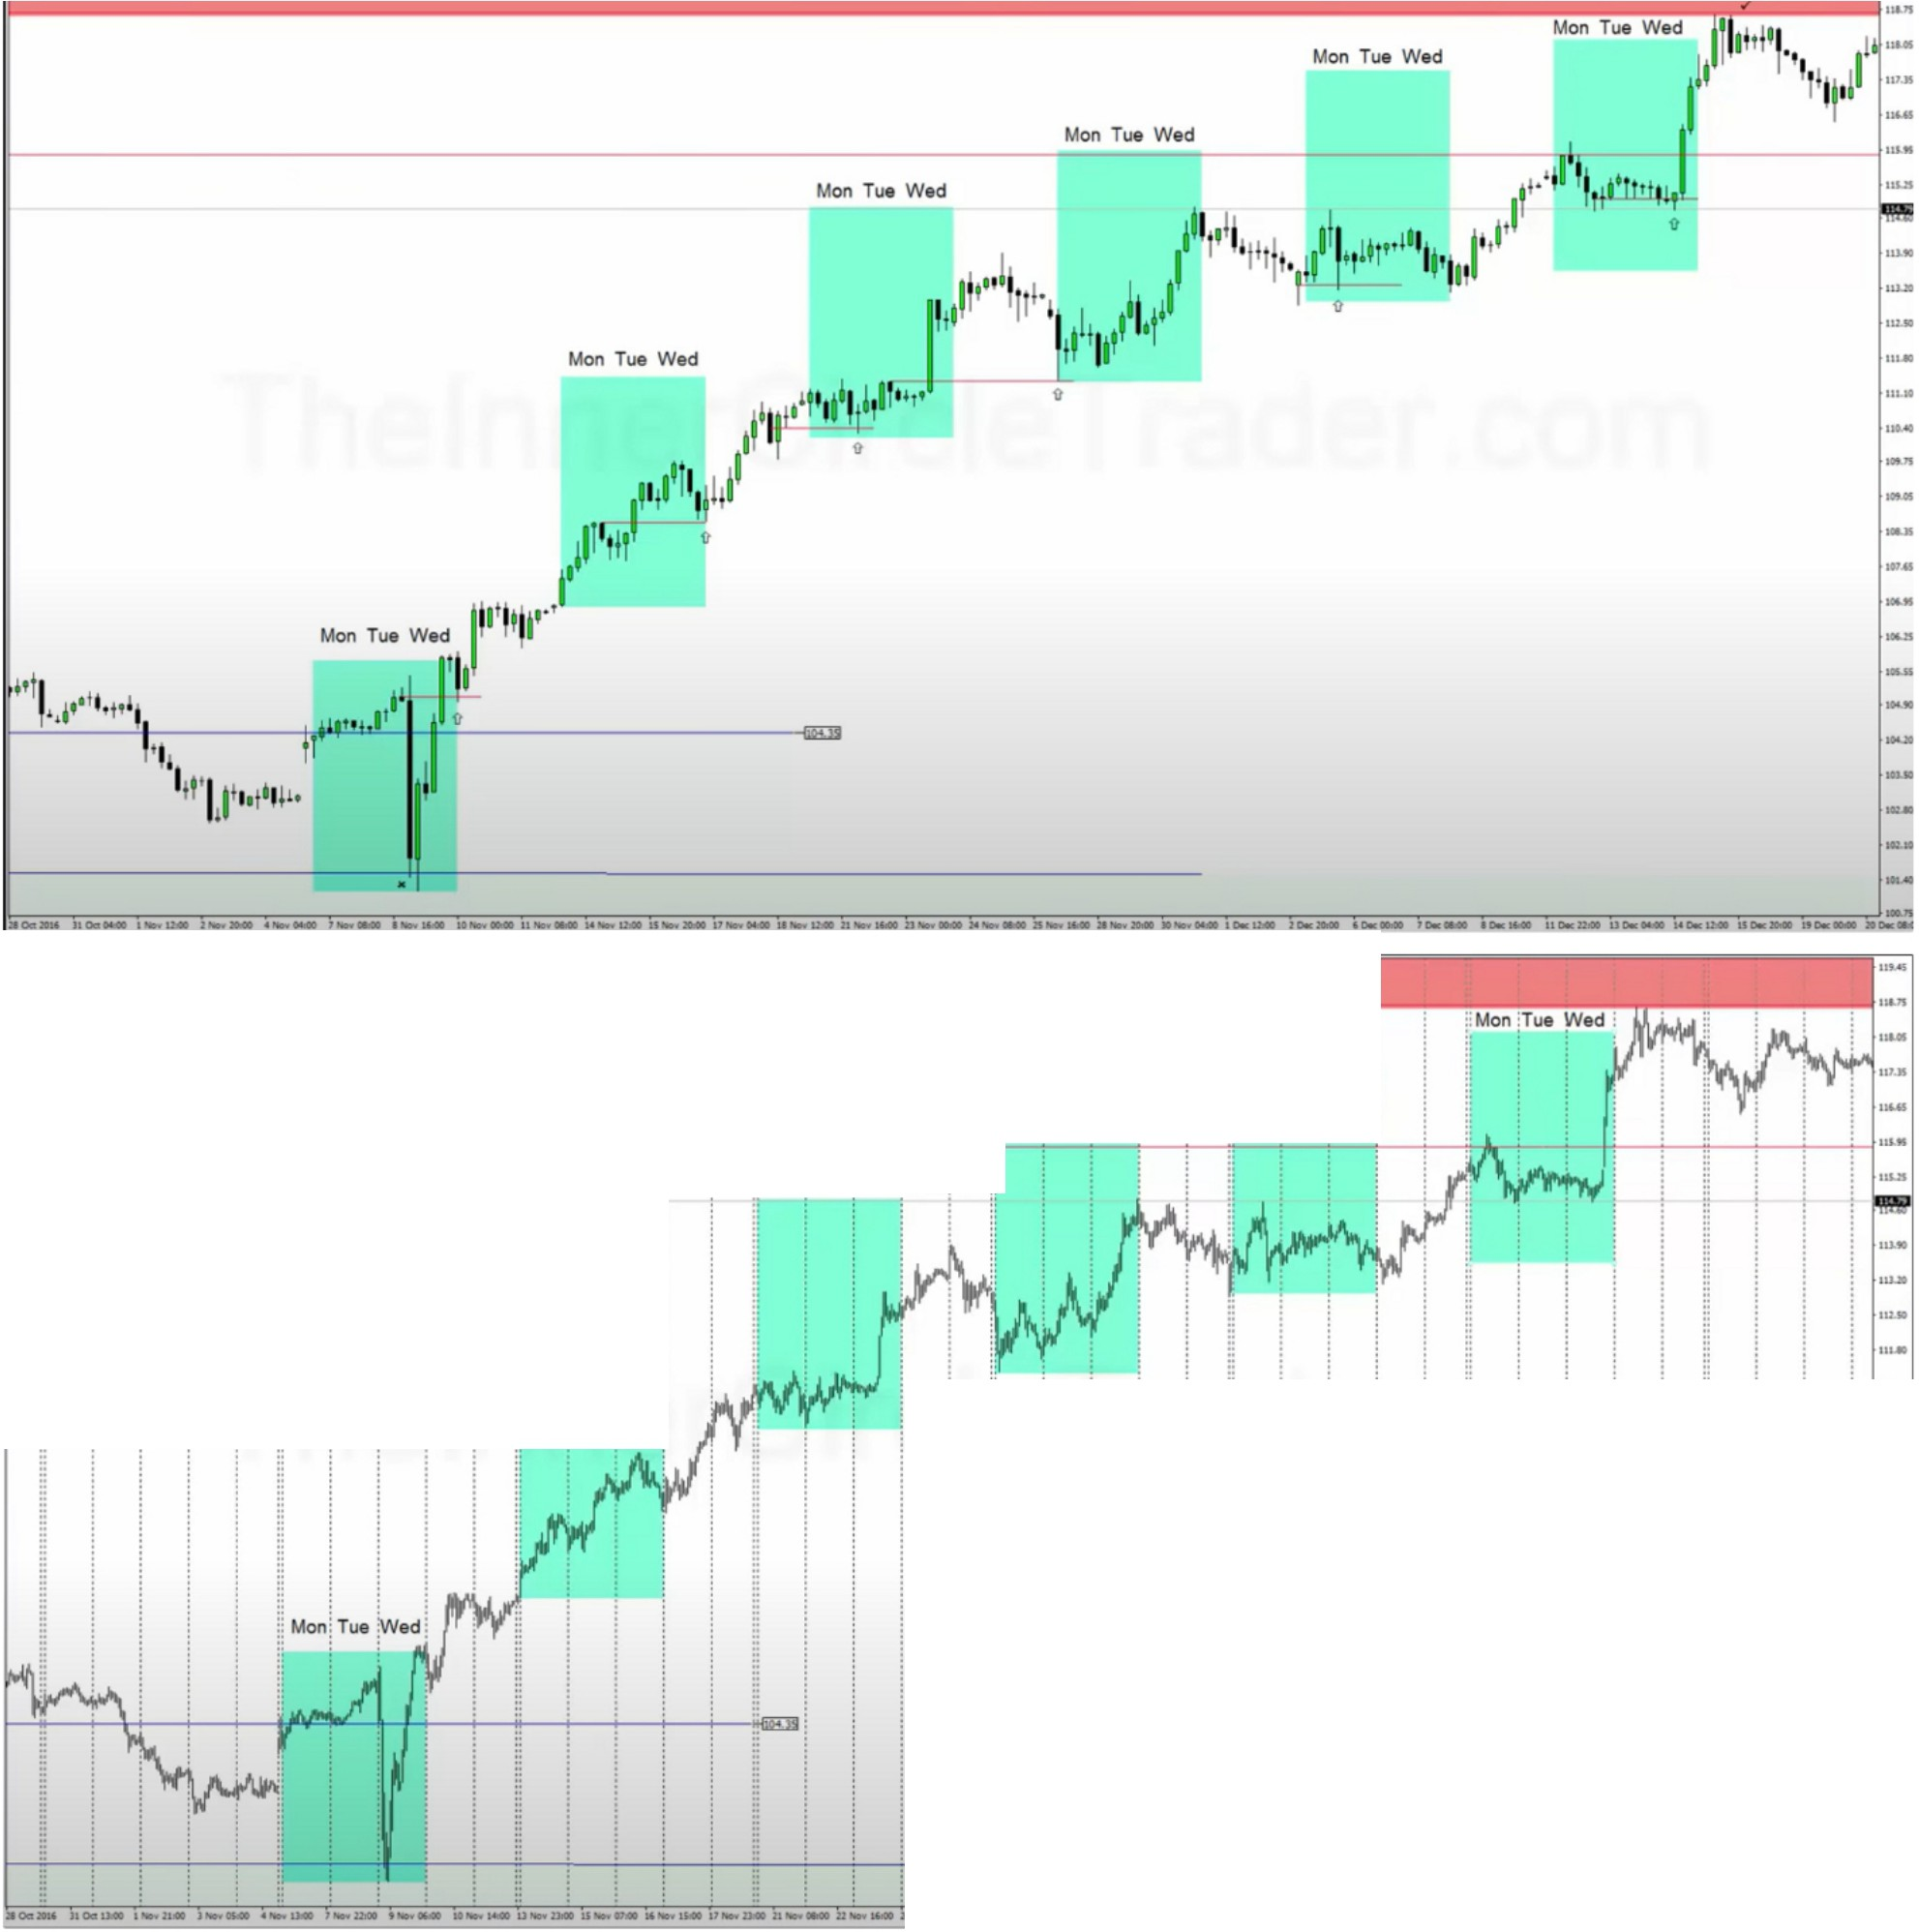

ii i i

*ii* **Mon:Tueedj**

i--,,-,-_

-_ _,, , ,

,_,, ,

, ---,-., .--, _, ,,\!.**Monj Tue jWedj**

IT **Mo Tue!wed!**

\j **Mon;Tue Wed1**

Note when the Monday- Wednesday High 1s traded through - Pnce tends to expand aggressively towards the Monthly and or Weekly Premmm A.nay

,

If trough monday and wednesday the high of that period is broken on thursday or friday, generally thats an indication that we will move aggressively higher to out premium array

So monday trough wednesday range, if the high that gets formed in between that time on thursday or friday then thats a buy program, vice versa when bearish for a sell program

Arjo I Twitter, lnstagram I Linktree

Linktree. Make your link do more.

, https://t.co/HhmmTN1fUI

JavaScript is not available.

https://twitter.com/arjoio